

D.A.V. PUBLIC School

POWER GRID CAMPUS, BIHAR SHARIF (NALANDA)

(Affiliated to CBSE, New Delhi up to +2 Level)

**Home Assignment for Durga Puja (2025-2026) Class X**

**ENGLISH**

1. Solution of section B and C in fair copy from Half yearly question.
2. Solve two unseen passage (From group)
3. Madam rides the Bus- concept map
4. Drafting of ALS P.W. ( Only think about it)

**MATHS**

1. Solve exercises- 6.2,8.1,8.3,11.1

**S.SC**

**Geography**

1. Read ch-5 ( Mineral and energy resources)
2. Prepare some MCQ from ch-5
3. Practice sample question paper from ch-1 to 4.

**Civics**-

1. Read ch-4 (Political parties)
2. Prepare MCQ from ch-4
3. Practics sample question paper from ch1 to 4.

**Economics**

_________

**History**

1. ________

**HINDI**

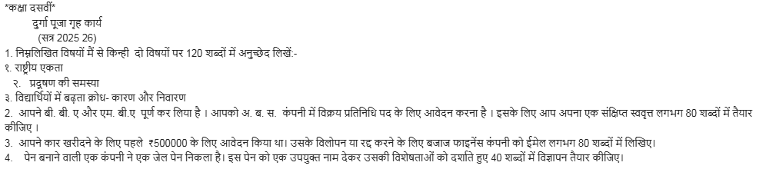

**ICT**

1. What is a macro in a spreadsheet? Write the steps to record a macro.

2. What is What-if Analysis Tool? Write the steps to perform Goal Seek in LibreOffice Calc.

3. What is Data Consolidation? Write the steps to consolidate marks of three sections into one sheet.

4. Write the steps to insert a header and footer in a digital document.

5. Mention any four self-management skills that help in preparing for board exams.

6. Write the steps to protect a spreadsheet with a password.

**Note: All students will do their Durga Puja holiday homework in their computer fair copy.**

**SANSKRIT**

**______**

**SCIECNE**

**Physics:**

1. Solve 25 numericals problems from the ch-9 9( any publication)
2. Draw ray diagram for formation of Image in spherical lens on chart paper (Compulsory)

**Chemistry:-**

1. Solve Given worksheet of chapter Acid ,bases and salt & Ch-3 metal and non metals

**(Biology)**

1. **Draw any one on the chart paper**
2. **[a] regeneration in planaria**

**[b] Human Brain**

**[c] Longitudnal crss section of flower**

**3. Answer the following questions**

**[a] How does variation ensure survival of a species.**

**[b] Advantage and disadvantage of endocrine system or nervous system.**

**[c] How does auxin facilitate phototropism and geotropism.**

**[d] Differentitate between blood plasma,lymph and glomerular filterate.**

**[e] What will be the effect on digestion due to malfunctioning on these organs/glands.[a] Liver [b] Pancreas [c] Gastric Glands**